Workshop: Integrating the Samsung Mobile SDK

**Exercise 1: Enabling MultiWindow in your app**

1. Start with “feels” project and open AndroidManifest.xml file
2. Locate <uses-sdk> node and update android:minSdkVersion=*"18"*
3. Locate the <application> node. Add the following meta-data tag.

<application>

<meta-data

android:name=*"com.samsung.android.sdk.multiwindow.enable"*

android:value=*"true"*/>

1. Locate the <intent-filter> tag under <activity> node. Add the following category:

<intent-filter>

<action android:name=*"android.intent.action.MAIN" />*

<category android:name=*"android.intent.category.LAUNCHER" />*

<category

android:name=*"android.intent.category.MULTIWINDOW_LAUNCHER"*/>

1. Save the AndroidManifest.xml file and install the app on the phone.
2. Open MultiWindow Tray on phone by selecting white tab on the side of the screen. Your multiwindow-enabled app should be at the top of the tray.

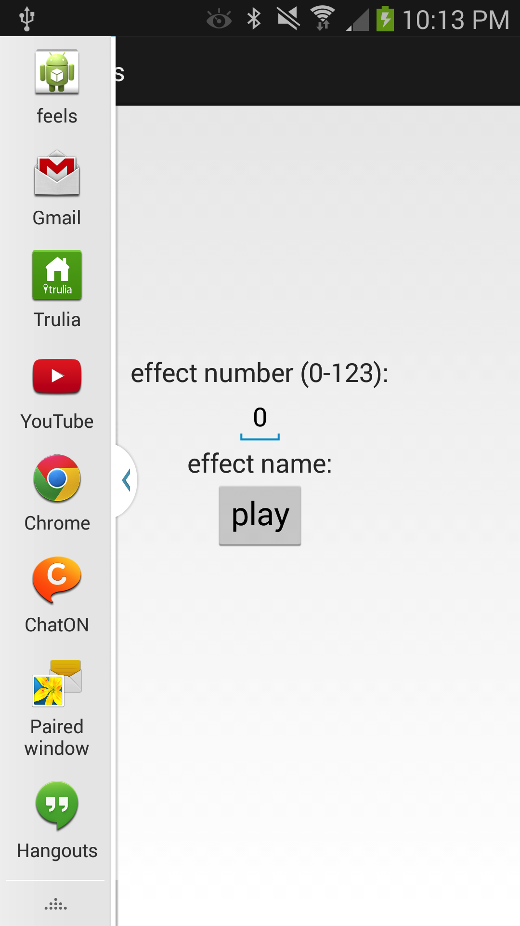

1. Select another application from the tray and begin dragging it to the bottom half of the screen to open it in a second window.

|  |  |
| --- | --- |
|  |  |

***Extra Credit: Adding MultiInstance***

1. Go back to AndroidManifest.xml file and locate the <application> node again.
2. Add the following line below the other <meta-data> tag.

<meta-data

android:name=*"com.samsung.android.sdk.multiwindow.multiinstance.enable"*

android:value=*"true"*/>

1. Install the app and check to see that it’s MultiInstance.
   1. Open the MultiWindow Tray
   2. There should be a white arrow beside the “feels” icon
   3. Select the “feels” app to open two thumbnails.
   4. Select the “+” thumbnail and two separate instances of the app should open up.

|  |  |
| --- | --- |
|  |  |

***Extra Credit: Configure for Pen Mode***

1. Go back to AndroidManifest.xml file and locate the <application> node again.
2. Add the following line below the other <meta-data> tag.

<meta-data

android:name=*"com.samsung.android.sdk.multiwindow.multiinstance.enable"*

android:value=*"true"*/>

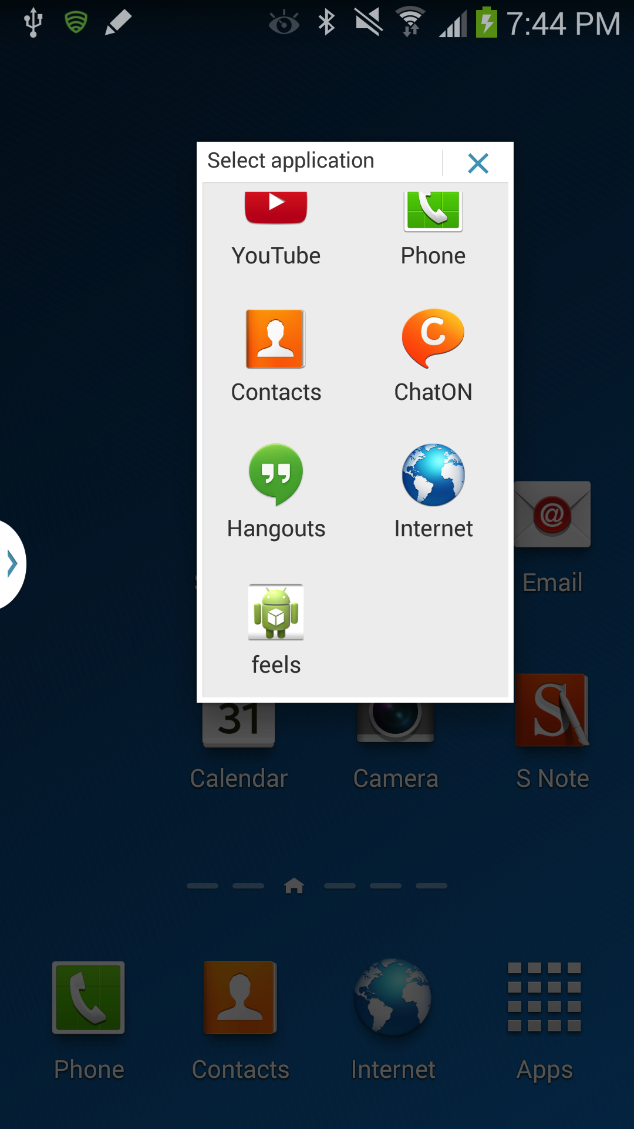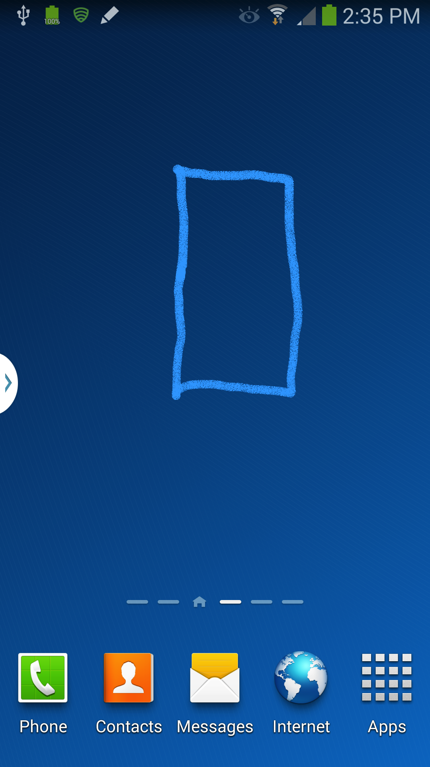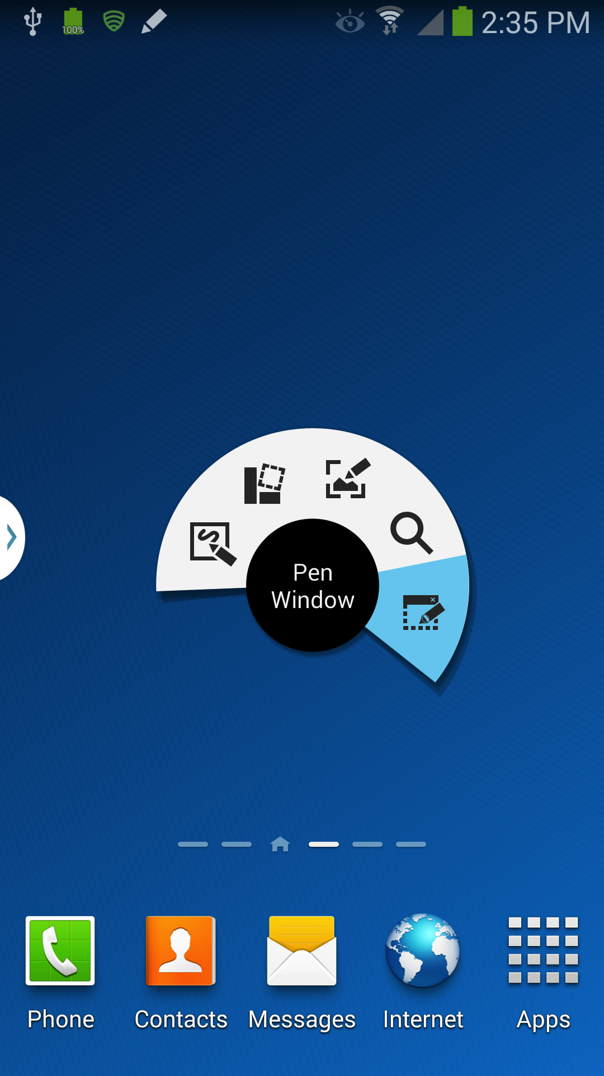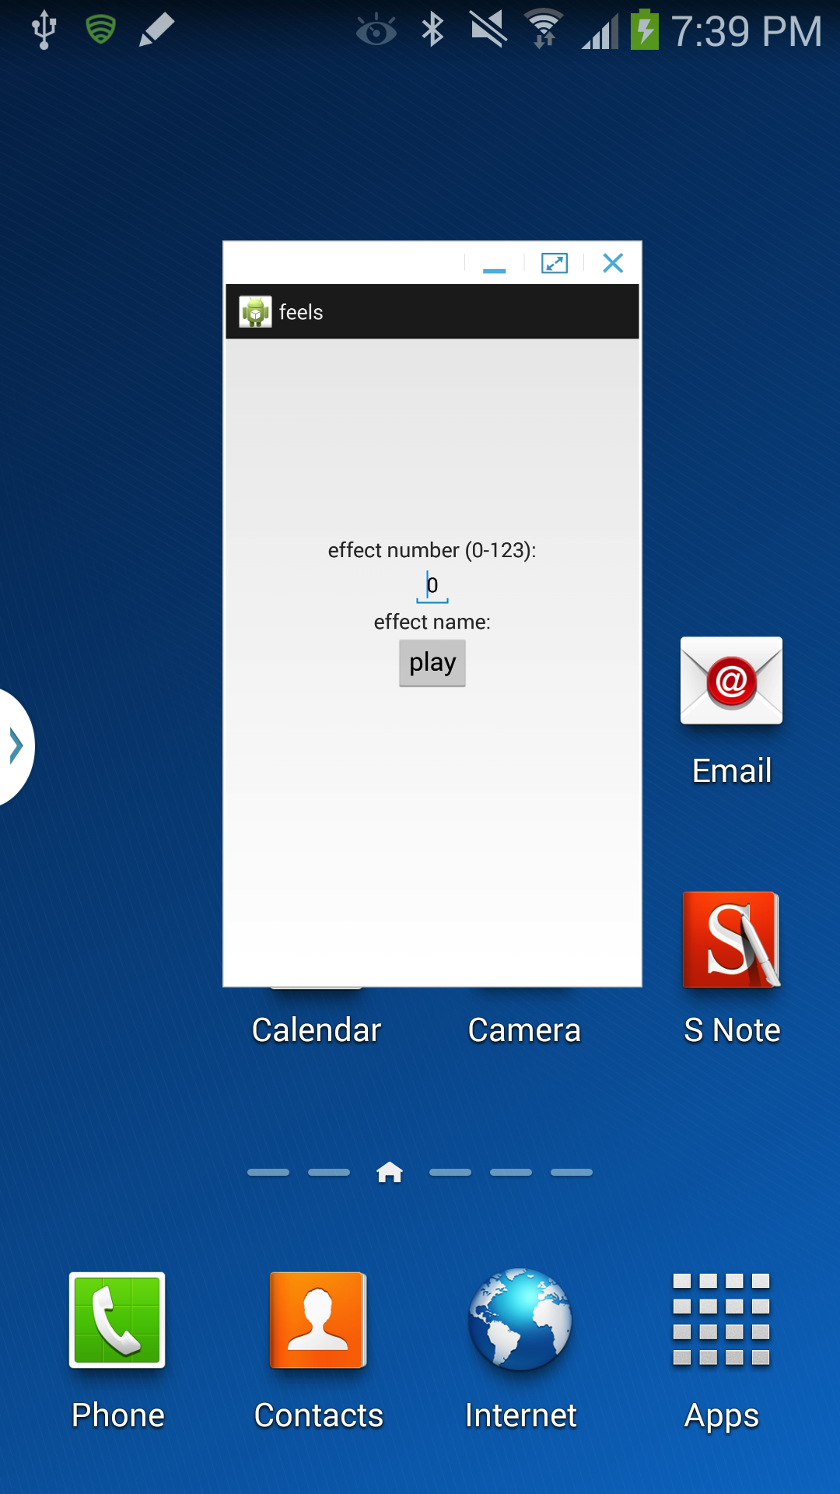

**Exercise 2: Adding Gestures**

1. Locate directory where you downloaded Samsung Mobile SDK.
   1. Locate the two JAR files under the …/1.0.3/Libs/gestures folder
2. Add gesture library to your project.
   1. Find the /libs folder under your feel project
   2. Copy and paste the two JAR files – gesture-v1.0.0.jar and sdk-v1.0.0.jar -- to the feels /libs folder
3. Open MainActivity.java file under the /src/com/example/feels directory.
4. Add the following variables above the onCreate() method in the MainActivity

RelativeLayout rl;

Sgesture mGesture;

**private** SgestureHand mSgestureHand;

To resolve missing classes, press <cmd><shift><O> to import the packages

1. Move the following line in your handleButton method up to the onCreate() method under the call to setContentView(). Remove the RelativeLayout type.

// move existing line in handleButton

RelativeLayout rl = (RelativeLayout) findViewById(R.id.*mylayout*);

// new line in onCreate under setContentView

rl = (RelativeLayout) findViewById(R.id.*mylayout*);

1. Add a new method called changeBackgroundColor() below handleButton(). Move the logic from handleButton() to changeBackGroundColor().

**public** **void** changeBackgroundColor() {

**int** r=0, g=0, b=0;

Random ran = **new** Random();

g = ran.nextInt(0x100);

r = ran.nextInt(0x100);

b = ran.nextInt(0x100);

Toast.*makeText*(this, "r="+r+ ",g="+g + ",b="+b,

Toast.*LENGTH_SHORT*).show();

**int** randomColor = 0xFF000000 + (r<<24) + (g<<16) + (b);

rl.setBackgroundColor( randomColor);

}

1. Replace the code in handleButton() with a call to changeBackgroundColor()

**public** **void** handleButton(View v) {

changeBackgroundColor();

}

At this point your application does exactly the same thing so stop and test your app.

1. Create a new method called initialize() to validate device support for gestures and add below changeBackgroundColor().

/**

* Verify that gesture is available on 4.3 Samsung device and

* set up listener for movement

*/

**public** **void** initialize() {

mGesture = **new** Sgesture();

**try** {

mGesture.initialize(**this**);

} **catch** (IllegalArgumentException e) {

e.printStackTrace();

Toast.*makeText*(**this**, "This device is not supported",

Toast.*LENGTH_LONG*).show();

finish();

} **catch** (SsdkUnsupportedException e) {

e.printStackTrace();

Toast.*makeText*(**this**, "This device is not supported",

Toast.*LENGTH_LONG*).show();

finish();

}

**if**(mGesture.isFeatureEnabled(Sgesture.*TYPE_HAND_PRIMITIVE*)){

mSgestureHand = **new**

SgestureHand(Looper.*getMainLooper*(),mGesture);

mSgestureHand.start(Sgesture.*TYPE_HAND_PRIMITIVE*,

changeHandListener);

}

}

To resolve missing classes, press <cmd><shift><O> to import the packages. Note, you will see an error until you add the listener in step 9.

1. Immediately below initialize, add the listener to handle gestures – changeHandListener(). It will call changeBackgroundColor() in onChanged() when a gesture is detected

**private** SgestureHand.ChangeListener changeHandListener = **new**

SgestureHand.ChangeListener() {

@Override

**public** **void** onChanged(SgestureHand.Info info) {

changeBackgroundColor();

};

};

1. Add a call to initialize() in onCreate()

@Override

**protected** **void** onCreate(Bundle savedInstanceState) {

**super**.onCreate(savedInstanceState);

setContentView(R.layout.*activity_main*);

rl = (RelativeLayout) findViewById(R.id.*mylayout*);

// initialize gesture

initialize();

}

1. You must stop the sensor when the application stops. Add the following routine below onCreate()

@Override

**protected** **void** onStop(){

**super**.onDestroy();

mSgestureHand.stop();

}

1. Install the app and test. Swipe your hand over the sensor, up/down or right/left, and you should see the color change. You can also open two instances of the app and swipe over the sensor. Both instances should respond to a color change.